1. Draw the electron diagram for each of the following molecules (showing electrons in the outermost shells only).
(a) F2 | (b) HCl
(c) Br2 | (d) H2S
(e) PH3 | (f) SiH4
(6 marks)

2. Draw the electron diagram for each of the following molecules (showing electrons in the outermost shells only).
(a) H2O | (b) CO2
(c) NF3 | (d) CCl4
(e) SO2 | (f) PCl3
(6 marks)

3. Draw the electron diagrams (showing electrons in the outermost shell only) of the compounds formed between the following pairs of elements.
(a) Hydrogen and Fluorine | (b) Carbon and Oxygen
(c) Nitrogen and Chlorine | (d) Sulphur and Hydrogen
(e) Phosphorus and Hydrogen | (f) Silicon and Fluorine
(6 marks)

4. Draw the electron diagram for each of the following molecules (showing electrons in the outermost shells only).
(a) HCN | (b) COCl2
(c) NOF | (d) CH2O
(e) COS | (f) N2F2
(6 marks)

5. Draw the electron diagram of the following molecules, showing electrons in the outermost shells only.
(a)
(i) HOCl | (ii) CNF
(iii) N2H2 | (iv) C2H2
(v) O2F2 | (vi) CS2
(6 marks)
(b) Which of the above molecules has the greatest number of lone pairs of electrons? (1 mark)
________________________________________________________________________
(c) Which of the above molecules has the least number of electrons? (1 mark)
________________________________________________________________________
(d) Which of the above molecules has / have double covalent bond in their molecules? (1 mark)
________________________________________________________________________
(e) Which of the above molecules has / have triple covalent bond in their molecules? (1 mark)
________________________________________________________________________

6. Consider the elements shown below:
Element | P | Q | R
Atomic number | 7 | 8 | 17
(a) Draw the electron diagram of a molecule of P, showing electrons in the outermost shells only. (1 mark)

(b) What is the type of chemical bond that joins the atoms together in a molecule of P? (1 mark)
________________________________________________________________________
(c) Compound M forms when Q reacts with R.
(i) Write the electronic arrangement of an atom of Q and that of an atom of R. (2 marks)
________________________________________________________________________
________________________________________________________________________
(ii) Draw the electron diagram of a molecule of M, showing electrons in the outermost shells only. (1 mark)

(iii) State the number of bond pairs and that of lone pairs in a molecule of M. (2 marks)
________________________________________________________________________
________________________________________________________________________
7. Consider the four elements W, X, Y and Z. (Note: the letters are NOT the symbols of the elements.)
Element | W | X | Y | Z
Atomic number | 6 | 9 | 16 | 18
(a) Two of these elements can combine to form a covalent compound. Give the formula of ONE possible covalent compound formed. (1 mark)
________________________________________________________________________
(b) Describe the bond formation in the covalent compound in (a) from atoms of the relevant elements. (2 marks)
________________________________________________________________________
________________________________________________________________________
________________________________________________________________________
(c) Draw the electron diagram for a molecule of the compound in (a), showing electrons in the outermost shells only. (1 mark)

8. The non-metallic element tellurium (Te) has six outermost shell electrons in its atom.
(a) To which group in the periodic table does tellurium belong? (1 mark)
________________________________________________________________________
(b) Hydrogen telluride is a compound made up of hydrogen and tellurium. It is known that hydrogen and tellurium is bound together by covalent bonding. Draw an electron diagram of hydrogen telluride, showing electrons in the outermost shells only. (1 mark)

9. Both oxygen and argon are gases under room conditions.
(a) Write the electronic arrangement of an argon atom. (1 mark)
________________________________________________________________________
(b) Draw the electron diagram of an oxygen molecule, showing electrons in the outermost shells only. (1 mark)

(c) Oxygen exists as diatomic molecules while argon exists as monoatomic molecules.
(i) Explain why monoatomic argon is stable. (1 mark)
________________________________________________________________________
________________________________________________________________________
(ii) Explain why diatomic oxygen is more stable than monoatomic oxygen. (2 marks)
________________________________________________________________________
________________________________________________________________________
________________________________________________________________________

10. The table below gives the melting points of Group VII elements.
Element | Melting point (°C)
Fluorine | –220
Chlorine | –101
Bromine | –7
Iodine | 114
(a) Explain why elements in Group VII exist as diatomic molecules. (2 marks)
________________________________________________________________________
________________________________________________________________________
________________________________________________________________________
(b) Name TWO other elements, apart from those in Group VII, which are diatomic. (2 marks)
________________________________________________________________________
(c) Draw an electron diagram of the compound formed from bromine and chlorine, showing electrons in the outermost shells only. (1 mark)

(d) Draw an electron diagram of the compound formed from oxygen and fluorine, showing electrons in the outermost shells only. (1 mark)

11. Give chemical formulae to the following covalent compounds.
 | Chemical name | Chemical formulae
(a) | Carbon dioxide
(b) | Sulphur dioxide
(c) | Nitrogen trifluoride
(d) | Carbon tetrachloride
(e) | Phosphorus pentachloride
(f) | Sulphur hexafluoride
(g) | Oxygen difluoride
(h) | Dinitrogen tetroxide
(i) | Dinitrogen pentoxide
(j) | Water
(k) | Ammonia
(l) | Methane
(m) | Hydrogen peroxide
(n) | Hydrogen chloride
(o) | Hydrogen sulphide
(p) | Carbon monoxide
12. Give chemical names to the following covalent compounds.
 | Chemical formulae | Chemical name
(a) | NO2
(b) | SF6
(c) | CO
(d) | PCl3
(e) | N2O
(f) | NCl3
(g) | P2O5
(h) | S2Cl2
(i) | O2F2
(j) | N2F4
(k) | SO3
(l) | NH3
(m) | CH4
(n) | H2O2
(o) | H2O
(p) | HF
13. Complete the following table.
Fill in each blank cell with the missing chemical name or chemical formula.
Chemical name | Chemical formula
Potassium sulphate
 | CO2
Sodium hydroxide
 | Ca(NO3)2
Sulphur hexafluoride
 | ZnSO4
Iron(III) chloride
 | CuSO4
Phosphorus trichloride
 | K2SO3
Aluminium hydroxide
 | N2O5
Ammonium carbonate
 | Li3N
Iron(III) oxide
 | NaNO2
Calcium carbonate
 | Mg3N2
Ammonia
 | SiF4
14. Complete the following table. (Relative atomic masses: H = 1.0, C = 12.0, N = 14.0, O = 16.0, F = 19.0, Na = 23.0, P = 31.0, S = 32.1, Cl = 35.5, K = 39.1, Ca = 40.1)
Chemical name | Chemical formula | Formula mass
Carbon dioxide
Water
Ammonia
Methane
Hydrogen peroxide
Sulphur trioxide
Nitrogen dioxide
Sodium chloride
Calcium carbonate
Potassium nitrate
Dinitrogen pentoxide
Sulphur hexafluoride
Carbon disulphide
Phosphorus trichloride
Hydrogen chloride
15. Complete the following table. (Relative atomic masses: H = 1.0, N = 14.0, O = 16.0, F = 19.0, S = 32.1, Cl = 35.5)
(a)
Electron diagram | Chemical name / Molecular formula / Relative molecular mass
Chemical name: Nitrogen
Molecular formula: __________
Relative molecular mass: __________
(b)
Electron diagram | Chemical name / Molecular formula / Relative molecular mass
Chemical name: Chlorine monofluoride
Molecular formula: __________
Relative molecular mass: __________
(c)
Electron diagram | Chemical name / Molecular formula / Relative molecular mass
Chemical name: Hydrogen sulphide
Molecular formula: __________
Relative molecular mass: __________
(9 marks)
16. The electron diagram of a molecule of methanoic acid is shown below.
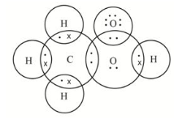
(a) Describe the formation of the C–H bond in a methanoic acid molecule. (1 mark)
________________________________________________________________________
________________________________________________________________________
(b) State the number of lone pairs of electrons on the left oxygen atom and on the right oxygen atom in the diagram (state which oxygen you count as left and right). (2 marks)
________________________________________________________________________
________________________________________________________________________
(c) Which two atoms in the molecule share a double covalent bond? (1 mark)
________________________________________________________________________
(d) Write the structural formula and molecular formula of methanoic acid. (2 marks)
________________________________________________________________________
________________________________________________________________________
________________________________________________________________________
17. Draw the electron diagrams (showing electrons in the outermost shell only) of the compounds formed between the following pairs of elements. Give the name of the compound formed.
(a) Hydrogen and Oxygen | (b) Carbon and Chlorine
Name of compound: | Name of compound:
(c) Nitrogen and Hydrogen | (d) Sulphur and Fluorine
Name of compound: ________________________ | Name of compound: ________________________
(e) Phosphorus and Chlorine | (f) Silicon and Fluorine
Name of compound: ________________________ | Name of compound: ________________________
(12 marks)

18. The following is a part of the Periodic Table which shows only six of the elements A to F. (Note: A to F are NOT the symbols of the elements.)
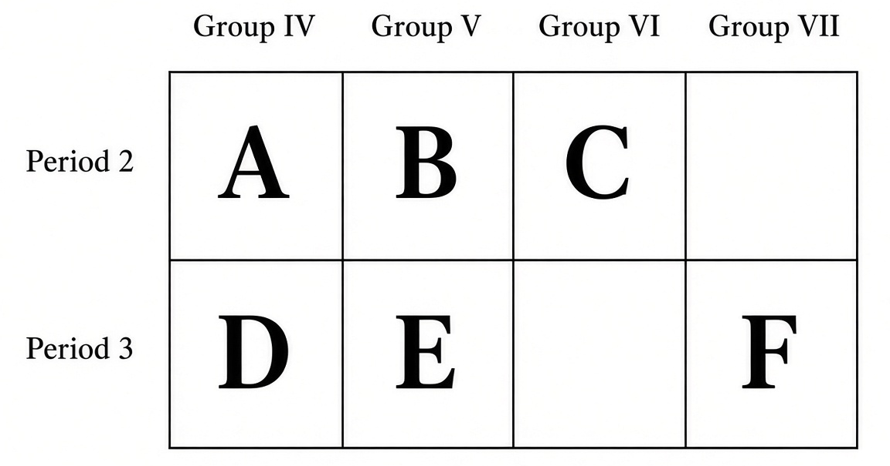
(a) Draw electron diagrams (showing electrons in the outermost shells only) for the compounds formed between
(i) A and C (1 mark)

(ii) B and F (1 mark)

(iii) D and F (1 mark)

(b) Draw electron diagrams (showing electrons in the outermost shells only) for a molecule of element C and a molecule of element F. (2 marks)
Molecule of C | Molecule of F

19. The following table lists the atomic numbers of four elements.
Element | G | H | J | K
Atomic number | 1 | 7 | 8 | 9
(a) Draw an electron diagram of a molecule formed between G and H, showing electrons in the outermost shells only. (1 mark)

(b) Draw an electron diagram of a molecule formed between G and J, showing electrons in the outermost shells only. (1 mark)

(c) Draw an electron diagram of a molecule formed between H and K, showing electrons in the outermost shells only. (1 mark)

(d) Circle the correct answer: The bond in the molecule in (b) is Ionic / Covalent. (1 mark)
20. What is meant by the term 'covalent bond'? Hence state what is meant by the term 'molecule'.
(2 marks)
________________________________________________________________________
________________________________________________________________________
________________________________________________________________________
________________________________________________________________________

21. When hydrogen chloride gas is passed into water, H3O+ ions will be formed. The formation of H3O+ involves the formation of dative covalent bond.
(a) What is meant by the term 'dative covalent bond'? (1 mark)
________________________________________________________________________
________________________________________________________________________
(b) Describe the formation of dative covalent bond using H3O+ as example. (3 marks)
________________________________________________________________________
________________________________________________________________________
________________________________________________________________________
________________________________________________________________________
(c) Draw the structural formula of a H3O+ ion. (1 mark)

(d) What is the chemical name of H3O+ ion? (1 mark)
________________________________________________________________________
22. Describe and explain the formation of dative covalent bond in the following species.
(a) NH4+ (3 marks)
________________________________________________________________________
________________________________________________________________________
________________________________________________________________________
________________________________________________________________________
(b) Formation of H3NBF3 from NH3 and BF3 (3 marks)
________________________________________________________________________
________________________________________________________________________
________________________________________________________________________
________________________________________________________________________
23. Dative covalent bond is present in some chemicals.
(a) BF3 molecules can form H3NBF3.
(i) Draw the electron diagram (showing ELECTRONS IN THE OUTERMOST SHELLS only) for NH3, BF3 and H3NBF3. (2 marks)

(ii) Write the structural formula for a H3NBF3 molecule, using an arrow (➔) to represent the dative covalent bond. (1 mark)
________________________________________________________________________
________________________________________________________________________

(b) Oxygen molecule can react with an oxygen atom to give an ozone molecule (O3).
(i) Describe the bond formation between oxygen molecule and oxygen atom. (2 marks)
________________________________________________________________________
________________________________________________________________________
________________________________________________________________________
(ii) Write the structural formula for an ozone molecule, using an arrow (➔) to represent the dative covalent bond. (1 mark)
________________________________________________________________________
________________________________________________________________________
(c) Nitrogen molecule can react with an oxygen atom to give a nitrous oxide molecule (N2O).
(i) Describe the bond formation between nitrogen molecule and oxygen atom. (2 marks)
________________________________________________________________________
________________________________________________________________________
________________________________________________________________________
(ii) Write the structural formula for a nitrous oxide molecule, using an arrow (➔) to represent the dative covalent bond. (1 mark)
________________________________________________________________________
________________________________________________________________________
24. Consider the molecule ammonia (NH3).
(a) Draw the electron diagram of a NH3 molecule, showing electrons in the outermost shells only. (1 mark)

(b) Draw the electron diagram of a BF3 molecule, showing electrons in the outermost shells only. (Hint: The B atom in BF3 does NOT have an octet structure). (1 mark)

(c) Describe the bond formation between ammonia and boron trifluoride. (1 mark)
________________________________________________________________________
________________________________________________________________________
________________________________________________________________________
(d) Draw the structural formula of F3BNH3. (1 mark)

25. Both carbon monoxide and nitric acid have a dative covalent bond in their own molecules.
(a) Below is the electron diagram for a molecule of carbon monoxide.
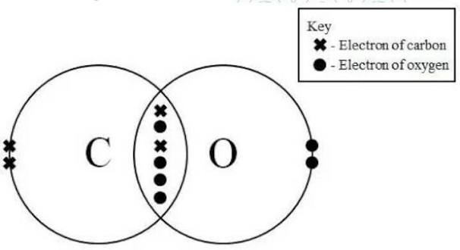
(i) How many bond pairs of electrons are there in a carbon monoxide molecule? (1 mark)
________________________________________________________________________
(ii) How many lone pairs of electrons are there in a carbon monoxide molecule? (1 mark)
________________________________________________________________________
(iii) Write the structural formula for a molecule of carbon monoxide. Use an arrow (➔) to represent any dative covalent bond formed. (1 mark)
________________________________________________________________________
________________________________________________________________________
(b) The diagram below shows the bonding in one nitric acid molecule.
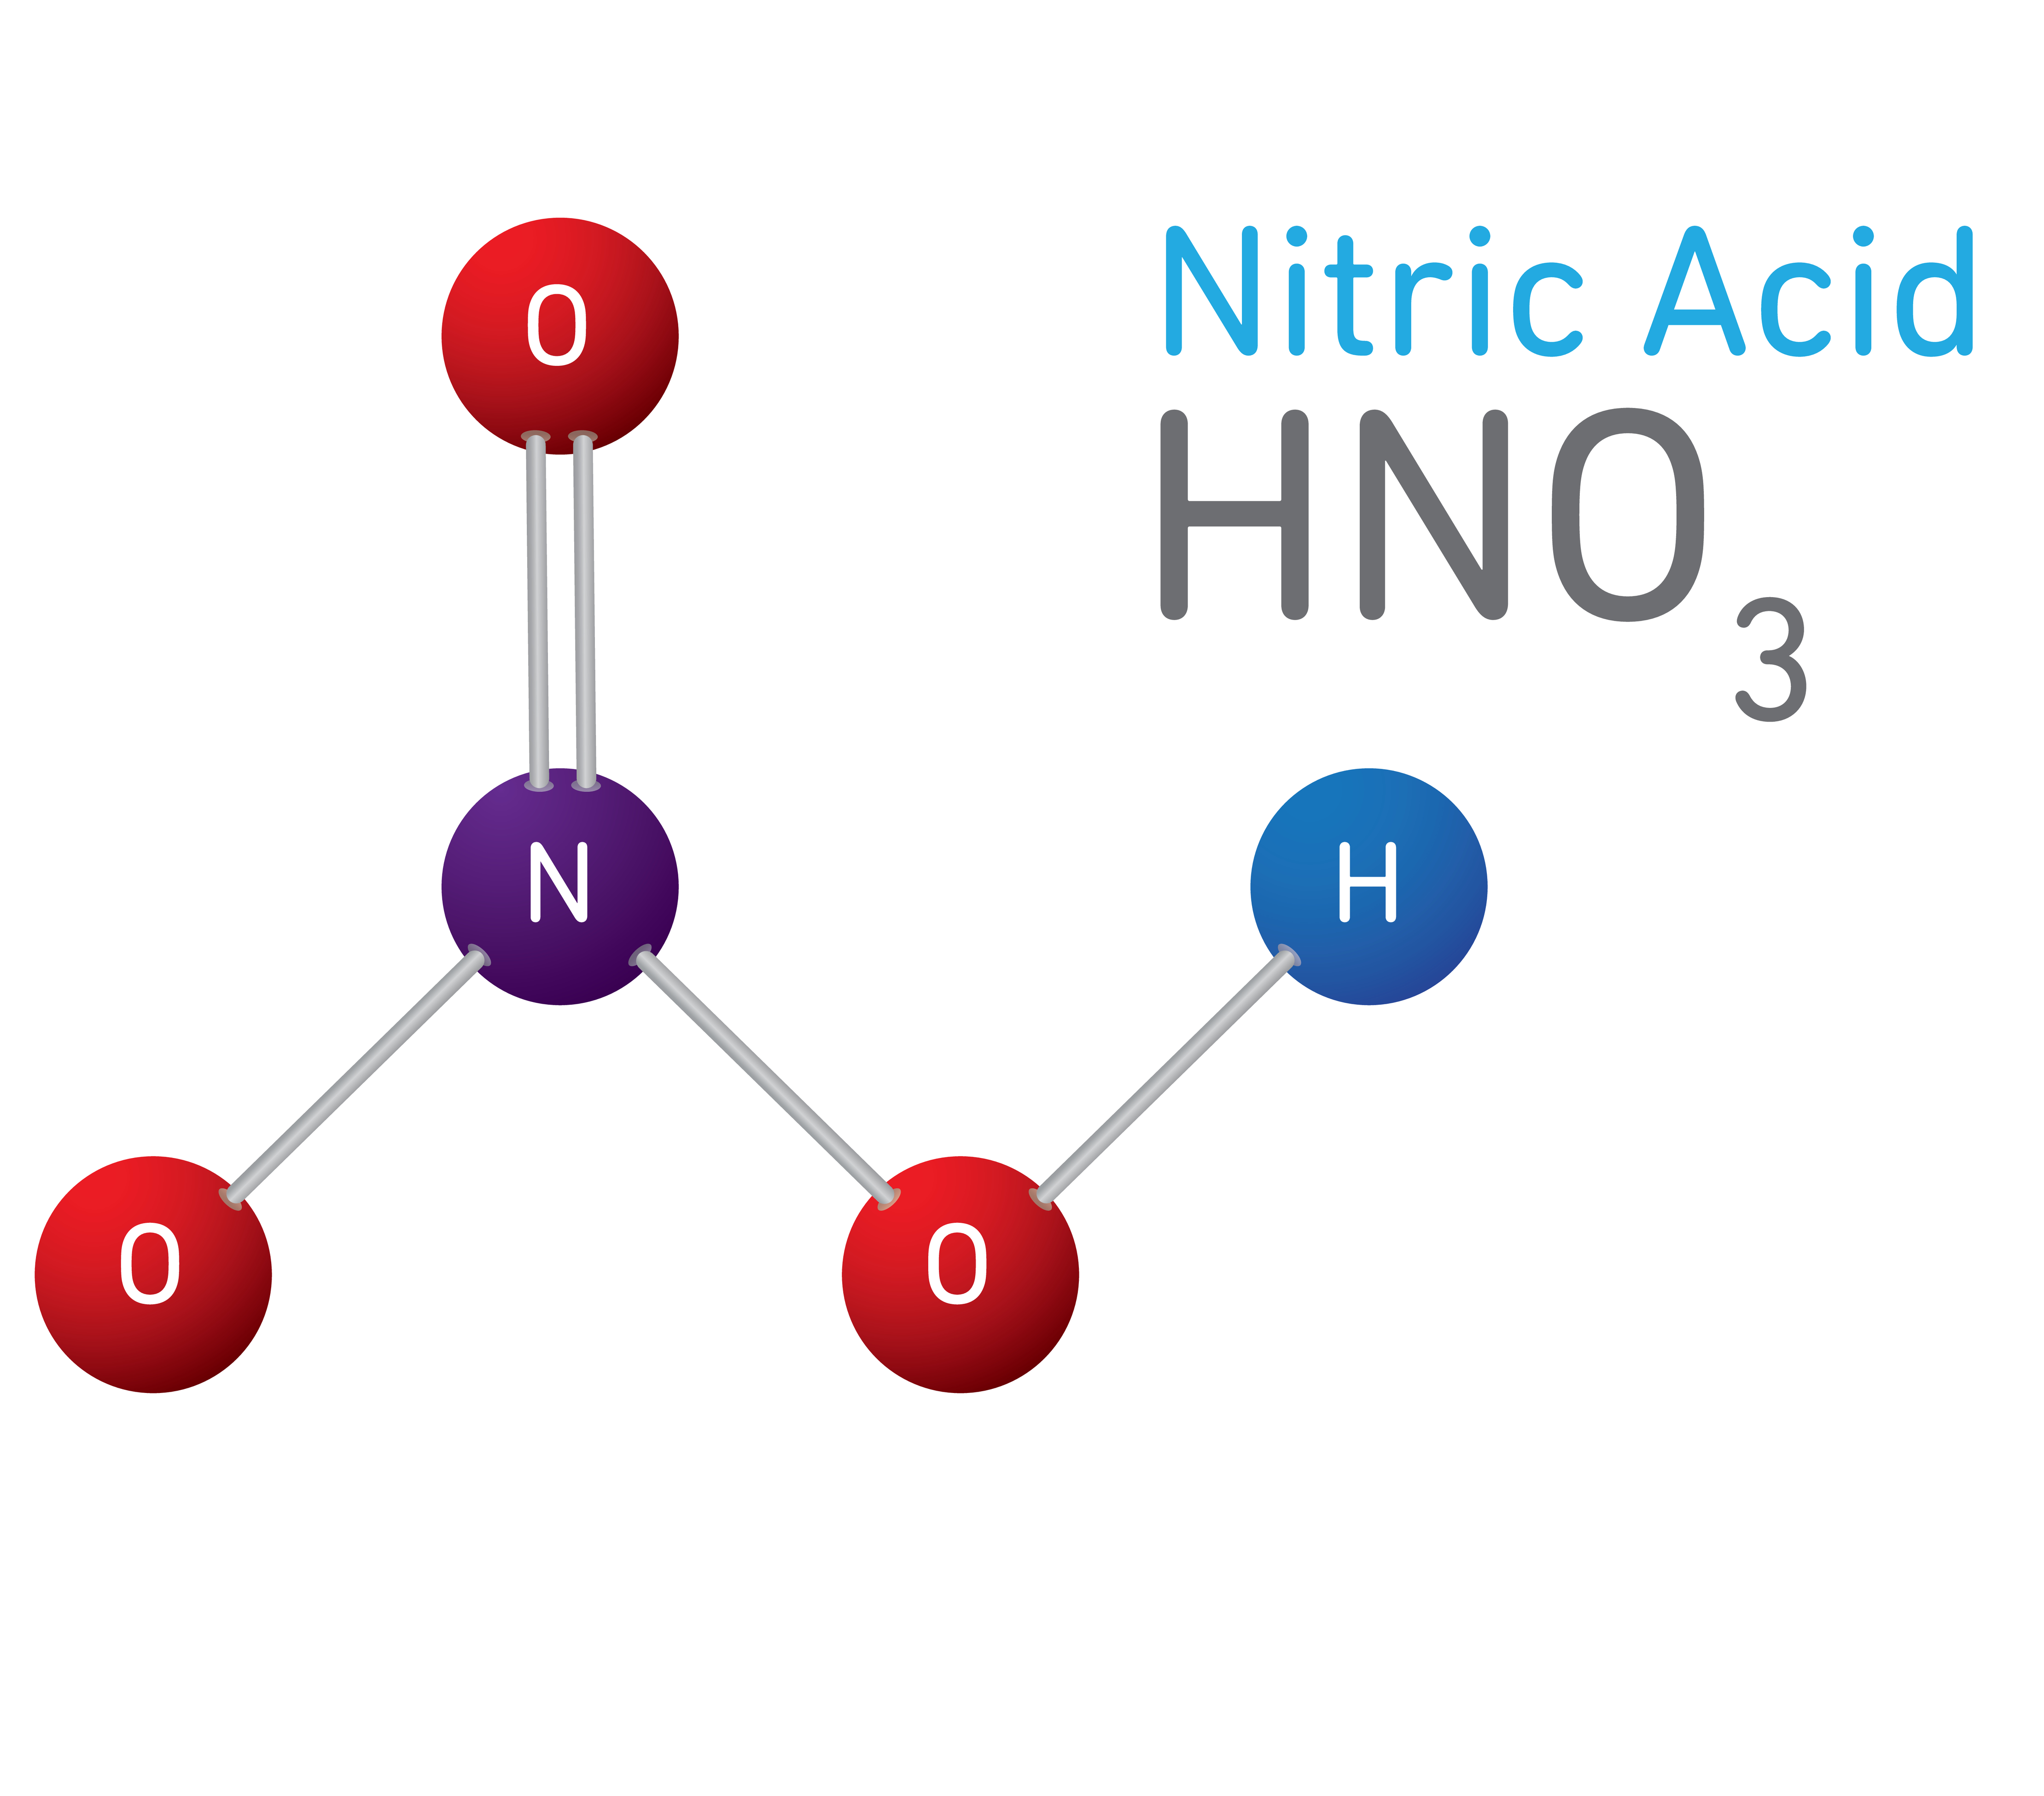
Draw the electron diagram for a nitric acid molecule, showing electrons in the outermost shells only. Use crosses to represent the electron of the H atom; dots to represent the electrons of the O atoms and small circles for the electrons of the N atom. (1 mark)

26. State FOUR rules for naming covalent compounds. Hence name the compounds with formulae CO2, PCl5 and N2O4.
(7 marks)
________________________________________________________________________
________________________________________________________________________
________________________________________________________________________
________________________________________________________________________
________________________________________________________________________
________________________________________________________________________
________________________________________________________________________
________________________________________________________________________
27. Complete the summary table about chemical bonding. Circle the correct answer in each box where options are given.
 | Ionic bond | Metallic bond | Covalent bond
Nature | Non-directional electrostatic attraction between cations and anions  /  Directional electrostatic attraction between shared electrons and two nuclei of the bonded atoms | Non-directional electrostatic attraction between metal ions and sea of delocalized electrons  /  Directional electrostatic attraction between shared electrons and two nuclei of the bonded atoms | Directional electrostatic attraction between shared electrons and two nuclei of the bonded atoms  /  Non-directional electrostatic attraction between cations and anions
Formation | Transfer of electron(s) from one atom (group of atoms) to another  /  Sharing of outermost shell electrons between two atoms | Escape of outermost shell electrons from metal atoms  /  Transfer of electron(s) from one atom to another | Sharing of outermost shell electrons between two atoms  /  Escape of outermost shell electrons from metal atoms
(6 marks)

Answer
1.
(a)–(f) Electron diagrams (outermost shells only): F2; HCl; Br2; H2S; PH3; SiH4. Apply: If an atom needs n electrons to attain an octet structure, n of its outermost shell electrons is shared. In a covalent bond, both atoms contribute equal number of electrons during sharing. (H: 1 (duplet); Group VII: 1; Group VI: 2; Group V: 3; Group IV: 4.)
Source: topic-02-microscopic-world-i.pdf p.9
2.
(a)–(f) Electron diagrams: H2O; CO2; NF3; CCl4; SO2; PCl3. For molecule with ABX pattern, A is the central atom. Ensure all non-central atoms become stable (H becomes duplet by sharing 1 electron; O becomes octet by sharing 2 electrons with C).
Source: topic-02-microscopic-world-i.pdf p.9
3.
(a) HF (b) CO2 (c) NCl3 (d) H2S (e) PH3 (f) SiF4 (electron diagrams, outermost shell only).
Source: topic-02-microscopic-world-i.pdf p.9–10; naming series p.11
4.
(a) HCN (b) COCl2 (c) NOF (d) CH2O (e) COS (f) N2F2. For COCl2: Place the C, O and Cl atoms (C is the central atom as its group number is lowest); Ensure all non-central atoms become stable (Cl shares 1 electron with C, O shares 2 electrons with C). For NOF: Place the N, O and F atoms (N is the central atom as its group number is lowest); Ensure all non-central atoms become stable (F shares 1 electron with N, O shares 2 electrons with N); Fill in the unused electron for central atom N (5 – 2 – 1 = 2 for N atom). For N2F2: For molecule with AxBy pattern, the atoms should be placed symmetrically. Atoms with lowest group number (i.e. N) should be placed in the middle; Each N atom should form 3 bonds. Therefore two N atoms should from 3 – 1 (already formed with F) = 2 bonds.
Source: topic-02-microscopic-world-i.pdf p.10
5.
(a) Electron diagrams: HOCl; CNF; N2H2; C2H2; O2F2; CS2.
Source: topic-02-microscopic-world-i.pdf p.9–10
(b) O2F2
(c) C2H2
(d) N2H2; CS2
(e) C2H2; CNF
6.
(a) Electron diagram of N2: Since N needs 3 electron to become octet, each N atom shares 3 electrons; Fill in the unused electron for each N atom (5 – 3 = 2 for each N atom).
Source: topic-02-microscopic-world-i.pdf p.9 Example 2
(b) Covalent bond [Covalent bond is the strong directional electrostatic attraction between the shared electrons and the two nuclei of the bonded atoms. It is formed by sharing of outermost shell electrons between two atoms]
Source: topic-02-microscopic-world-i.pdf p.9
(c)(i) Q: 2,6 R: 2,8,7
Source: topic-02-microscopic-world-i.pdf p.1 electronic arrangement table
(c)(ii) Electron diagram of OCl2 / Cl2O (oxygen dichloride): O central, each Cl shares 1 electron with O; unused electrons on O: 6 – 1×2 = 4 (two lone pairs).
Source: topic-02-microscopic-world-i.pdf p.9
(c)(iii) 2 bond pairs and 8 lone pairs (2 on O + 3 on each Cl).
7.
(a) e.g. CF4 / SF2 / SF6 / OF2 (any one valid covalent formula from W=6, X=9, Y=16, Z=18; Z is noble gas and does not form the compound).
Source: topic-02-microscopic-world-i.pdf p.1, p.9
(b) In a covalent bond, both atoms contribute equal number of electrons during sharing. If an atom needs n electrons to attain an octet structure, n of its outermost shell electrons is shared.
Source: topic-02-microscopic-world-i.pdf p.9 General rule 1–2
(c) Corresponding electron diagram for the formula given in (a).
Source: topic-02-microscopic-world-i.pdf p.9
8.
(a) Group VI
Source: topic-02-microscopic-world-i.pdf p.9 (Group VI needs 2 electrons to attain an octet structure)
(b)( Electron diagram of H2Te analogous to H2S / H2O pattern: Te central, two H, two bonding pairs and two lone pairs on Te.
Source: topic-02-microscopic-world-i.pdf p.9 Example 3 pattern
9.
(a) 2,8,8
Source: topic-02-microscopic-world-i.pdf p.1 / p.5 Argon (Ar) 2,8,8
(b) Electron diagram of O2: each O needs 2 electrons to become octet, so each O atom shares 2 electrons (double bond); unused electrons on each O: 6 – 2 = 4.
Source: topic-02-microscopic-world-i.pdf p.9
(c)(i) Noble gases are unreactive / inert since they have an octet structure (duplet in helium) in their outermost shell.
Source: topic-02-microscopic-world-i.pdf p.5
(c)(ii) Monoatomic oxygen atoms are unstable because they do not have an octet structure in their outermost shell. They tend to share outermost shell electrons with another oxygen atom, forming a covalent bond. In this way, each oxygen atom has a stable octet. [If an atom needs n electrons to attain an octet structure, n of its outermost shell electrons is shared.]
Source: topic-02-microscopic-world-i.pdf p.5, p.9
10.
(a) An atom of a Group VII element has 7 outermost shell electrons / needs 1 electron to attain an octet structure. Each Group VII atom can obtain the stable electronic arrangement of an atom of a noble gas by sharing one outermost shell electron with another Group VII atom. [In a covalent bond, both atoms contribute equal number of electrons during sharing.]
Source: topic-02-microscopic-world-i.pdf p.9
(b) Hydrogen / Oxygen / Nitrogen (Any two)
Source: topic-02-microscopic-world-i.pdf p.1 non-metals; diatomic examples in notes
(c) Electron diagram of BrCl (single bond; three lone pairs on each atom).
Source: topic-02-microscopic-world-i.pdf p.9 Cl2 pattern
(d) Electron diagram of OF2: O central, each F shares 1 electron with O.
Source: topic-02-microscopic-world-i.pdf p.9
11.
(a) Carbon dioxide: CO2
(b) Sulphur dioxide: SO2
(c) Nitrogen trifluoride: NF3
(d) Carbon tetrachloride: CCl4
(e) Phosphorus pentachloride: PCl5
(f) Sulphur hexafluoride: SF6
(g) Oxygen difluoride: OF2
(h) Dinitrogen tetroxide: N2O4
(i) Dinitrogen pentoxide: N2O5
(j) Water: H2O
(k) Ammonia: NH3
(l) Methane: CH4
(m) Hydrogen peroxide: H2O2
(n) Hydrogen chloride: HCl
(o) Hydrogen sulphide: H2S
(p) Carbon monoxide: CO
Naming basis: Element occurs first in the following series. (Formula of water is H2O, NOT OH2) B, Si, C, P, N, H, S, I, Br, Cl, O, F; Mono (1), di (2), tri (3), tetra (4), penta (5), hexa (6) can indicate the number of atoms of that element in the compound; Name of the second element ends up with -ide (e.g. carbon dioxide, not carbon dioxygen); Some hydrogen-containing compounds have special names: CH4: Methane; NH3: Ammonia; H2O: Water; H2O2: Hydrogen peroxide.
Source: topic-02-microscopic-world-i.pdf p.11
12.
(a) NO2: Nitrogen dioxide
(b) SF6: Sulphur hexafluoride
(c) CO: Carbon monoxide
(d) PCl3: Phosphorus trichloride
(e) N2O: Dinitrogen monoxide / Nitrous oxide
(f) NCl3: Nitrogen trichloride
(g) P2O5: Diphosphorus pentoxide
(h) S2Cl2: Disulphur dichloride
(i) O2F2: Dioxygen difluoride
(j) N2F4: Dinitrogen tetrafluoride
(k) SO3: Sulphur trioxide
(l) NH3: Ammonia
(m) CH4: Methane
(n) H2O2: Hydrogen peroxide
(o) H2O: Water
(p) HF: Hydrogen fluoride
CH4: Methane; NH3: Ammonia; H2O: Water; H2O2: Hydrogen peroxide.
Source: topic-02-microscopic-world-i.pdf p.11
13.
Potassium sulphate — K2SO4
Carbon dioxide — CO2
Sodium hydroxide — NaOH
Calcium nitrate — Ca(NO3)2
Sulphur hexafluoride — SF6
Zinc sulphate — ZnSO4
Iron(III) chloride — FeCl3
Copper(II) sulphate — CuSO4
Phosphorus trichloride — PCl3
Potassium sulphite — K2SO3
Aluminium hydroxide — Al(OH)3
Dinitrogen pentoxide — N2O5
Ammonium carbonate — (NH4)2CO3
Lithium nitride — Li3N
Iron(III) oxide — Fe2O3
Sodium nitrite — NaNO2
Calcium carbonate — CaCO3
Magnesium nitride — Mg3N2
Ammonia — NH3
Silicon tetrafluoride — SiF4
Ion formulae/names from notes: SO42- Sulphate ion; OH- Hydroxide ion; NO3- Nitrate ion; SO32- Sulphite ion; CO32- Carbonate ion; NH4+ Ammonium ion; NO2- Nitrite ion; N3- Nitride ion; Na+ Sodium ion; K+ Potassium ion; Ca2+ Calcium ion; Zn2+ Zinc ion; Fe3+ Iron(III) ion; Cu2+ Copper(II) ion; Al3+ Aluminium ion; Li / Mg from atomic table; Chemical formula examples pattern: Na3N; Al2O3; CaS.
Source: topic-02-microscopic-world-i.pdf p.7–8, p.11
14.
Carbon dioxide: CO2; Formula mass = 12.0 + 16.0×2 = 44.0
Water: H2O; Formula mass = 1.0×2 + 16.0 = 18.0
Ammonia: NH3; Formula mass = 14.0 + 1.0×3 = 17.0
Methane: CH4; Formula mass = 12.0 + 1.0×4 = 16.0
Hydrogen peroxide: H2O2; Formula mass = 1.0×2 + 16.0×2 = 34.0
Sulphur trioxide: SO3; Formula mass = 32.1 + 16.0×3 = 80.1
Nitrogen dioxide: NO2; Formula mass = 14.0 + 16.0×2 = 46.0
Sodium chloride: NaCl; Formula mass = 23.0 + 35.5 = 58.5
Calcium carbonate: CaCO3; Formula mass = 40.1 + 12.0 + 16.0×3 = 100.1
Potassium nitrate: KNO3; Formula mass = 39.1 + 14.0 + 16.0×3 = 101.1
Dinitrogen pentoxide: N2O5; Formula mass = 14.0×2 + 16.0×5 = 108.0
Sulphur hexafluoride: SF6; Formula mass = 32.1 + 19.0×6 = 146.1
Carbon disulphide: CS2; Formula mass = 12.0 + 32.1×2 = 76.2
Phosphorus trichloride: PCl3; Formula mass = 31.0 + 35.5×3 = 137.5
Hydrogen chloride: HCl; Formula mass = 1.0 + 35.5 = 36.5
Special names: CH4: Methane; NH3: Ammonia; H2O: Water; H2O2: Hydrogen peroxide.
Source: topic-02-microscopic-world-i.pdf p.11
15.
(a) Electron diagram of N2 as in Example 2; Molecular formula: N2; Relative molecular mass: 14.0×2 = 28.0
Source: topic-02-microscopic-world-i.pdf p.9
(b) Electron diagram of ClF (Cl2 pattern); Molecular formula: ClF; Relative molecular mass: 35.5 + 19.0 = 54.5
Source: topic-02-microscopic-world-i.pdf p.9
(c) Electron diagram of H2S (H2O pattern); Molecular formula: H2S; Relative molecular mass: 1.0×2 + 32.1 = 34.1
Source: topic-02-microscopic-world-i.pdf p.9
16.
(a) The C–H bond forms by sharing of a pair of electrons between the C and H atoms, one from each atom. [In a covalent bond, both atoms contribute equal number of electrons during sharing.]
Source: topic-02-microscopic-world-i.pdf p.9
(b) Each O atom has 2 lone pairs of electrons (carbonyl O and hydroxyl O).
(c) C and O (the carbonyl oxygen).
(d) Molecular formula: CH2O2; Structural formula: HCOOH (H–C(=O)–OH).
17.
(a) Electron diagram of H2O; Name of compound: Water
Source: topic-02-microscopic-world-i.pdf p.9, p.11
(b) Electron diagram of CCl4; Name of compound: Carbon tetrachloride
Source: topic-02-microscopic-world-i.pdf p.11
(c) Electron diagram of NH3; Name of compound: Ammonia
Source: topic-02-microscopic-world-i.pdf p.9, p.11
(d) Electron diagram of SF2; Name of compound: Sulphur difluoride
Source: topic-02-microscopic-world-i.pdf p.9, p.11
(e) Electron diagram of PCl3; Name of compound: Phosphorus trichloride
Source: topic-02-microscopic-world-i.pdf p.11
(f) Electron diagram of SiF4; Name of compound: Silicon tetrafluoride
Source: topic-02-microscopic-world-i.pdf p.11
18.
(a)(i) Electron diagram of CO2: Place the C and O atoms (For molecule with ABX pattern, A is the central atom); Ensure all non-central atoms become stable (O becomes octet by sharing 2 electrons with C); Fill in the unused electron for central atom C (All 4 electrons of C are used, no electrons need to be filled).
Source: topic-02-microscopic-world-i.pdf p.9 Example 4
(a)(ii) Electron diagram of NCl3 (B = N, F = Cl): N central; each Cl shares 1 electron with N; Fill in the unused electron for central atom N (5 – 1×3 = 2 for N atom).
Source: topic-02-microscopic-world-i.pdf p.9 Example 3 pattern
(a)(iii) Electron diagram of SiCl4 (D = Si, F = Cl): Si central; each Cl shares 1 electron with Si.
Source: topic-02-microscopic-world-i.pdf p.9
(b) Molecule of C (O2): each O shares 2 electrons (double bond). Molecule of F (Cl2): Since Cl needs 1 electron to become octet, each Cl atom shares 1 electron; Fill in the unused electron for each Cl atom (7 – 1 = 6 for each Cl atom).
Source: topic-02-microscopic-world-i.pdf p.9 Example 1
19.
(a) NH3 electron diagram (Example 3).
Source: topic-02-microscopic-world-i.pdf p.9
(b) H2O electron diagram.
Source: topic-02-microscopic-world-i.pdf p.9
(c) NF3 electron diagram.
Source: topic-02-microscopic-world-i.pdf p.9
(d) Covalent
Source: topic-02-microscopic-world-i.pdf p.9
20.
Covalent bond is the strong directional electrostatic attraction between the shared electrons and the two nuclei of the bonded atoms. It is formed by sharing of outermost shell electrons between two atoms. Molecule is the smallest part of an element or a compound which can exist on its own under room conditions.
Source: topic-02-microscopic-world-i.pdf p.9
21.
(a) Dative covalent bond is a covalent bond formed between two atoms where both electrons of the shared pair are contributed by the same atom.
Source: topic-02-microscopic-world-i.pdf p.11
(b) H2O has 2 lone pairs of electrons on O atom. H+ does not have any electron in its outermost shell. It can accept 2 more electrons to attain a stable duplet structure. Dative covalent bond is formed when H2O shares its lone pair electrons on O to H+.
Source: topic-02-microscopic-world-i.pdf p.11 Example 1
(c) Structural formula of H3O+ (as in notes).
Source: topic-02-microscopic-world-i.pdf p.11
(d) Hydronium ion
Source: topic-02-microscopic-world-i.pdf p.11 (hydronium ion (H3O+))
22.
(a) NH3 + H+ ➔ NH4+. NH3 has a lone pair of electrons on N atom. H+ does not have any electron in its outermost shell. It can accept 2 more electrons to attain a stable duplet structure. Dative covalent bond is formed when NH3 shares its lone pair electrons on N to H+.
Source: topic-02-microscopic-world-i.pdf p.11
(b) NH3 has a lone pair of electrons on N atom. B atom in BF3 has 6 outermost shell electrons. It can accept 2 more electrons to attain a stable octet structure. Dative covalent bond is formed when NH3 shares its lone pair electrons on N to B atom in BF3.
Source: topic-02-microscopic-world-i.pdf p.11 Example 2
23.
(a)(i) Electron diagrams of NH3, BF3 and H3NBF3 (outermost shells only).
Source: topic-02-microscopic-world-i.pdf p.11
(a)(ii) Structural formula of H3NBF3 (arrow for dative bond).
Source: topic-02-microscopic-world-i.pdf p.11
(b)(i) O2 + O ➔ O3
Source: topic-02-microscopic-world-i.pdf p.11 Other examples
(b)(i) continued: Dative covalent bond is a covalent bond formed between two atoms where both electrons of the shared pair are contributed by the same atom. Oxygen molecule shares a lone pair of electrons with the oxygen atom to form ozone.
Source: topic-02-microscopic-world-i.pdf p.11
(b)(ii) Structural formula of O3 with arrow for dative covalent bond.
(c)(i) N2 + O ➔ N2O
Source: topic-02-microscopic-world-i.pdf p.11 Other examples
(c)(i) continued: Dative covalent bond is formed when nitrogen molecule shares its lone pair electrons with the oxygen atom.
Source: topic-02-microscopic-world-i.pdf p.11
(c)(ii) Structural formula of N2O with arrow for dative covalent bond.
24.
(a) Electron diagram of NH3 (Example 3).
Source: topic-02-microscopic-world-i.pdf p.9
(b) Electron diagram of BF3: B central with three F; B atom in BF3 has 6 outermost shell electrons.
Source: topic-02-microscopic-world-i.pdf p.11
(c) NH3 has a lone pair of electrons on N atom. B atom in BF3 has 6 outermost shell electrons. It can accept 2 more electrons to attain a stable octet structure. Dative covalent bond is formed when NH3 shares its lone pair electrons on N to B atom in BF3.
Source: topic-02-microscopic-world-i.pdf p.11
(d) Structural formula of H3NBF3 / F3BNH3.
Source: topic-02-microscopic-world-i.pdf p.11
25.
(a)(i) 3
Source: topic-02-microscopic-world-i.pdf p.11 (CO listed under dative covalent bond examples)
(a)(ii) 2
(a)(iii) Structural formula of CO with arrow for dative covalent bond.
Source: topic-02-microscopic-world-i.pdf p.11
(b) Electron diagram of HNO3 / nitric acid with dative bond as required; Dative covalent bond is a covalent bond formed between two atoms where both electrons of the shared pair are contributed by the same atom.
Source: topic-02-microscopic-world-i.pdf p.11
26.
1. Element occurs first in the following series. (Formula of water is H2O, NOT OH2) B, Si, C, P, N, H, S, I, Br, Cl, O, F
Source: topic-02-microscopic-world-i.pdf p.11
2. Mono (1), di (2), tri (3), tetra (4), penta (5), hexa (6) can indicate the number of atoms of that element in the compound
Source: topic-02-microscopic-world-i.pdf p.11
3. Name of the second element ends up with -ide (e.g. carbon dioxide, not carbon dioxygen)
Source: topic-02-microscopic-world-i.pdf p.11
4. Some hydrogen-containing compounds have special names CH4: Methane; NH3: Ammonia; H2O: Water; H2O2: Hydrogen peroxide
Source: topic-02-microscopic-world-i.pdf p.11
CO2: carbon dioxide; PCl5: phosphorus pentachloride; N2O4: dinitrogen tetroxide
Source: topic-02-microscopic-world-i.pdf p.11
27.
Ionic bond — Nature: Non-directional electrostatic attraction between cations and anions; Formation: Transfer of electron(s) from one atom (group of atoms) to another
Source: topic-02-microscopic-world-i.pdf p.11
Metallic bond — Nature: Non-directional electrostatic attraction between metal ions and sea of delocalized electrons; Formation: Escape of outermost shell electrons from metal atoms
Source: topic-02-microscopic-world-i.pdf p.11
Covalent bond — Nature: Directional electrostatic attraction between shared electrons and two nuclei of the bonded atoms; Formation: Sharing of outermost shell electrons between two atoms
Source: topic-02-microscopic-world-i.pdf p.11

